Zafra kazmi

Sap id: 56030

Data Base – 08

**Task:**

Create an ER diagram for LANGUAGE-LEARNING PROGRESS TRACKER. The users interact with the system in order to learn languages and get lessons for each language and track their progress. Each user as his name, email, address when he registered himself to the application. User can learn the languages bases on their difficulty levels. Each language has resources associated with it. The languages are taught through lessons containing content according to the difficulty level. The application displays the progress of the user with his grades, completion status, test scores. A user can learn different languages. Each language has multiple lessons. User can get have various lessons as well.

**ERD**

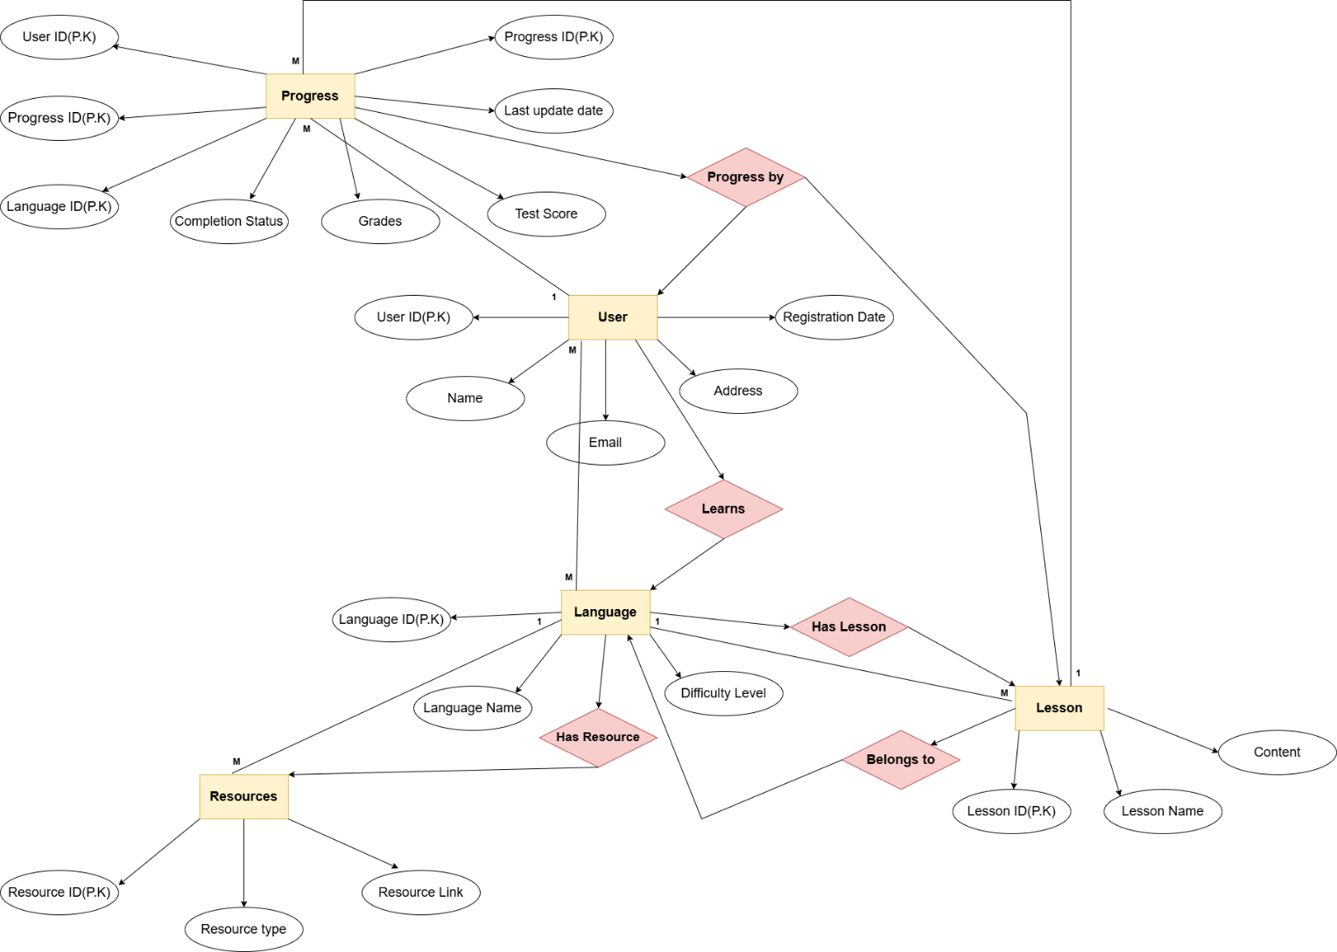

|  |  |  |  |
| --- | --- | --- | --- |
| Entity 1 | Entity 2 | Relationship Type | Description |
| User | Language | Many-to-Many | A user can learn multiple languages, and a language can be learned by multiple users. |
| User | Progress | One-to-Many | A user has multiple progress records for different languages and lessons. |
| Language | Lesson | One-to-Many | A language consists of multiple lessons, but a lesson belongs to one language. |
| Language | Resource | One-to-Many | A language can have multiple resources, but a resource is linked to only one language. |
| Lesson | Progress | One-to-Many | Each lesson is tracked in user progress when a user completes it. |